Lab 2 Report

Junyoung Kwon (jkwon031) - 861274236

Jason Mendoza (jmend062) - 861275834

**Exercise 1**

1. Garage open at night-- A garage door sensor connects to PA0 (1 means door open), and a light sensor connects to PA1 (1 means light is sensed). Write a program that illuminates an LED connected to PB0 (1 means illuminate) if the garage door is open at night.

**PA0 = garage door sensor (input), PA1 = light sensor (input), PB0 = LED (output)**

|  |  |  |
| --- | --- | --- |
| Input | Input | Output |
| PA1 | PA0 | PB0 |
| 0 | 0 | 0 |
| 0 | 1 | 1 |
| 1 | 0 | 0 |
| 1 | 1 | 0 |

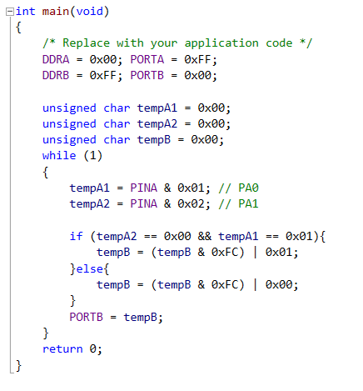

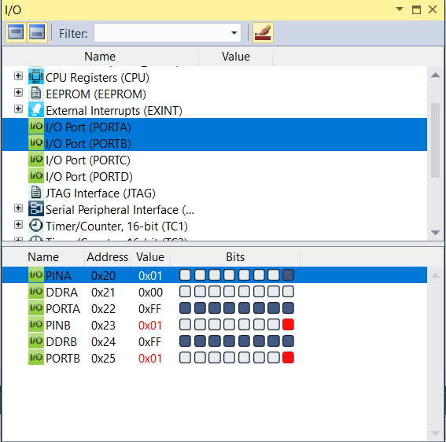

**Exercise 2**

1. Port A's pins 3 to 0, each connect to a parking space sensor, 1 meaning a car is parked in the space, of a four-space parking lot. Write a program that outputs in binary on port C the number of available spaces (Hint: declare a variable "unsigned char cntavail"; you can assign a number to a port as follows:   
   PORTC = cntavail;).

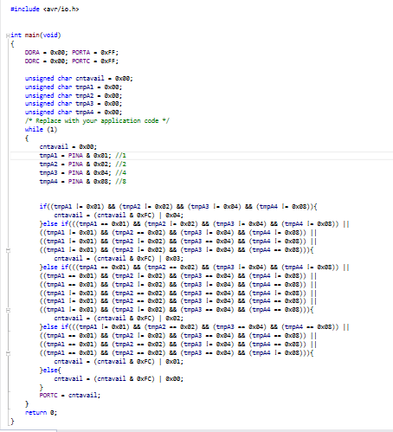

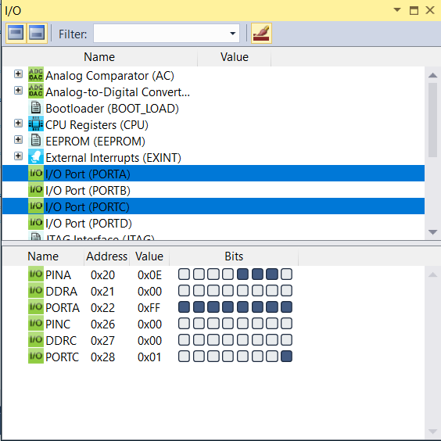

**Exercise 3**

1. Extend the previous program to still write the available spaces number, but only to PC3..PC0, **and** to set PC7 to 1 if the lot is full.

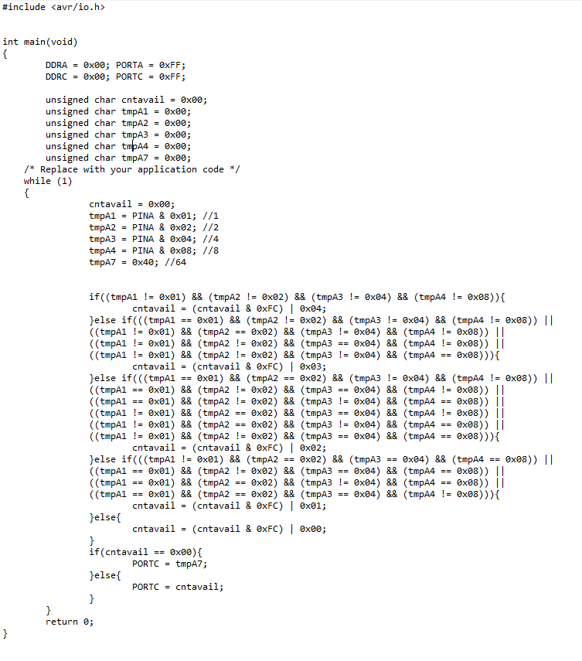

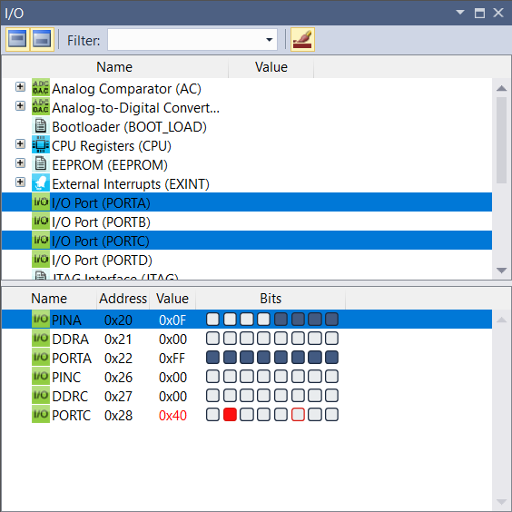

**Exercise 4**

1. (**Challenge**) An amusement park kid ride cart has three seats, with 8-bit weight sensors connected to ports A, B, and C (measuring from 0-255 kilograms). Set PD0 to 1 if the cart's total passenger weight exceeds the maximum of 140 kg. Also, the cart must be balanced: Set port PD1 to 1 if the difference between A and C exceeds 80 kg. Can you also devise a way to inform the ride operator of the approximate weight using the remaining bits on D? (Interesting note: Disneyland recently redid their "It's a Small World" ride because the average passenger weight has increased over the years, causing more boats to get stuck on the bottom).

(Hint: Use two intermediate variables to keep track of weight, one of the actual value and another being the shifted weight. Binary shift right by one is the same as dividing by two and binary shift left by one is the same as multiplying by two.)

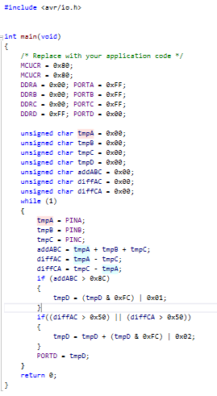

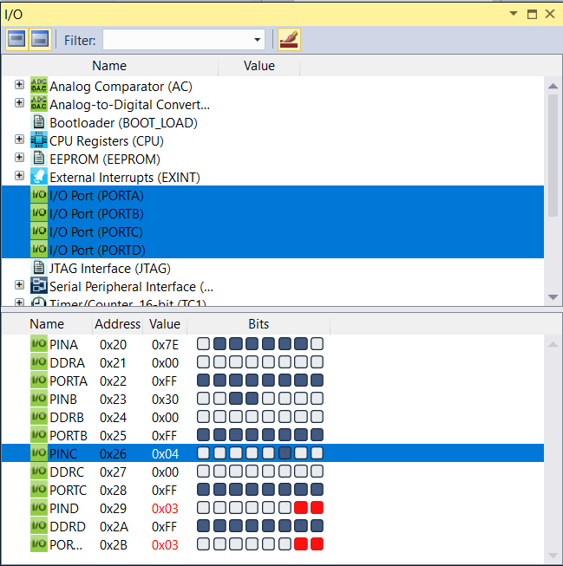

In order to capture the approximate value of the cart, shift the total by two bits to the right and cut off the two rightmost bits. So in the end PD0 and PD1 indicate total weight exceeded and weight difference exceeded and then PD2 through PD7 will be interpreted as 2^2 - 2^7 respectively. Bits 0 and 1 will not be represented but these values will be from 0-3 so not much info will be lost.